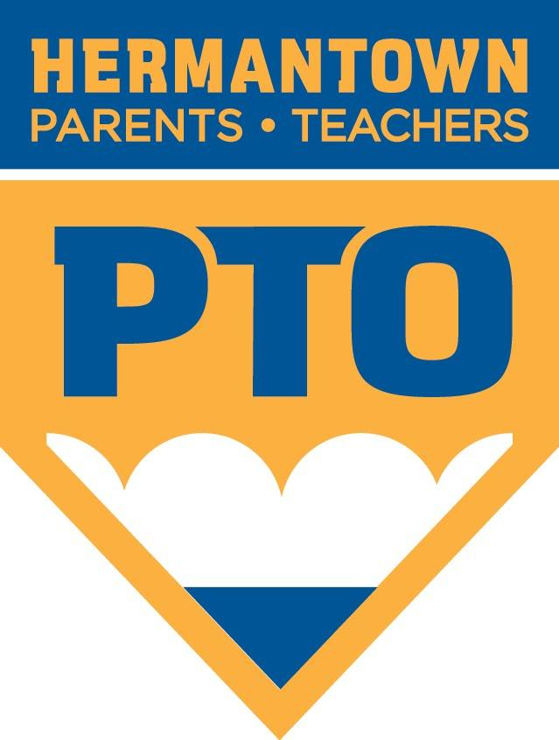
Hermantown Parent Teacher Organization
Thursday, September 19, 2019
6:00PM in the Hermantown Elementary School Teacher’s Lounge

Agenda
- Welcome and Introductions
- Treasurer’s Report
- Summer Business Updates
  - National Night Out Recap – Cyndi Frick
  - Open House Recap – Jaime Wentzel
- Principal Updates
- Funding Requests?
- Hungry Hawks
  - New Chair: Chad Roberg
  - September 19th – Dairy Queen
  - October 25th – Panera Bread
- Box Tops Contest – Tonya Gayeski, Jaime Wentzel
- Educational Challenge – Melissa Kaneski, Trista Swanson
- 5th Grade PTO Inclusion – Julie Lenz
- Announcements
  - Lost and Found – Jen Borich
  - Aluminum Cans – Jen Borich
- Shopper’s Day – Volunteer needed
- PTO Calendar of Events Review – Jen Borich
- Suggestions/Ideas?

